Names of the Strings
(Scroll)
G D A E
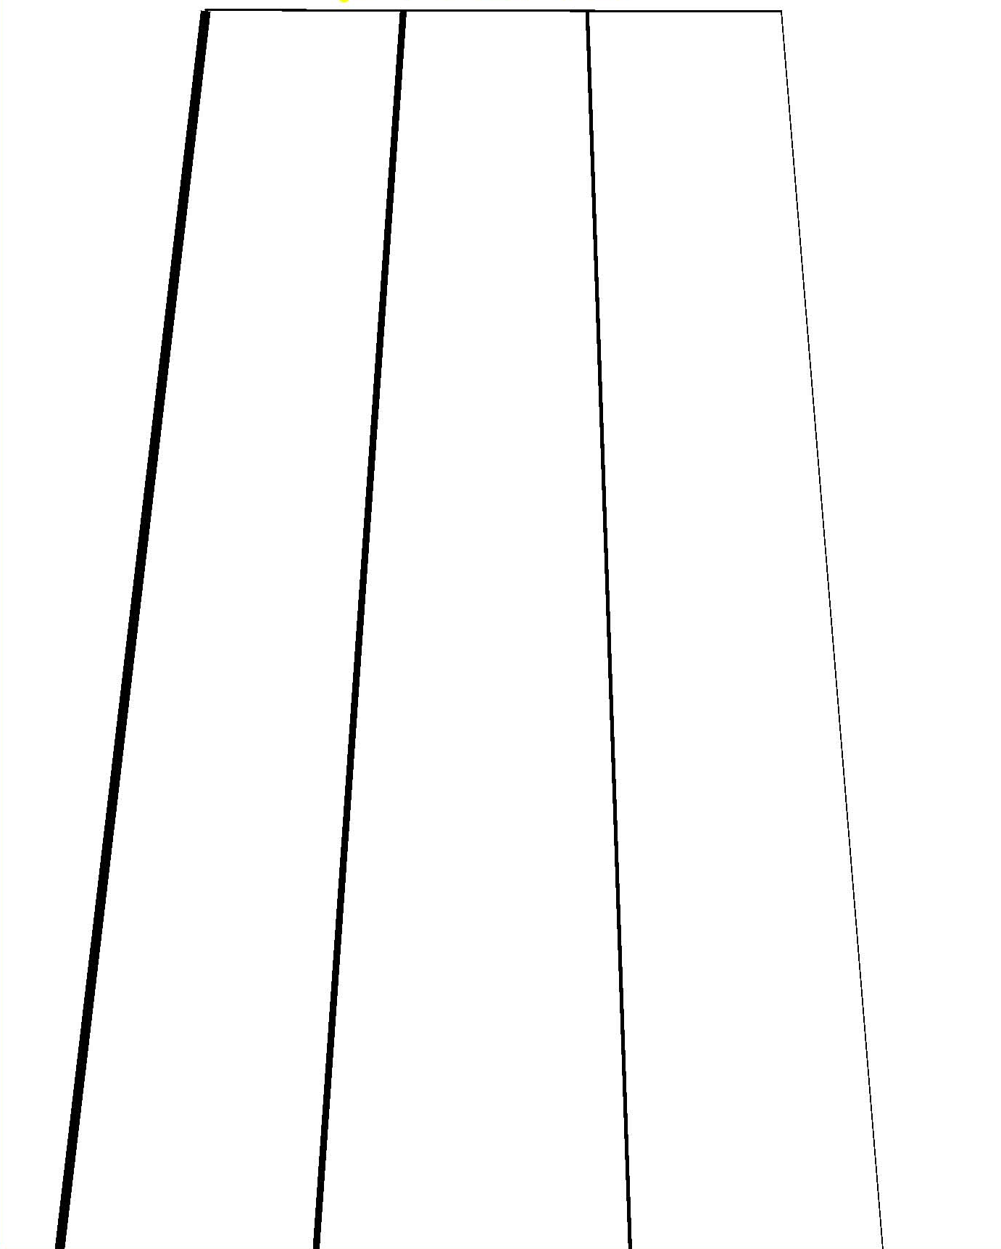
(Body)

